Week beginning 7th May 2018 – The Owls
It was a shorter week due to the bank holiday Monday, but the children returned to a busy workload! For English we wrote thank you letters to Hooke Court in which they described their favourite activities and the reasons behind their choices. The children also explained all the things they’d learnt from the trip.
In Maths we moved onto 3D shape and looked at ‘nets’ before constructing our own shapes out of straws and pipe cleaners. The children really enjoyed this and the work they produced was fantastic.
Introducing our topic on the Jurassic coast, we looked at the features, periods and areas of the dorset/devon coastline and watched some clips that explained why it is a world heritage site. The children then labelled and identified a coastal map that identifies the 3 periods of time from millions of years ago that are evidenced along our shores.
As usual, Mr Dailey came in to teach the children for their Athletics session in PE. and Mr Wash continued with tennis skills.
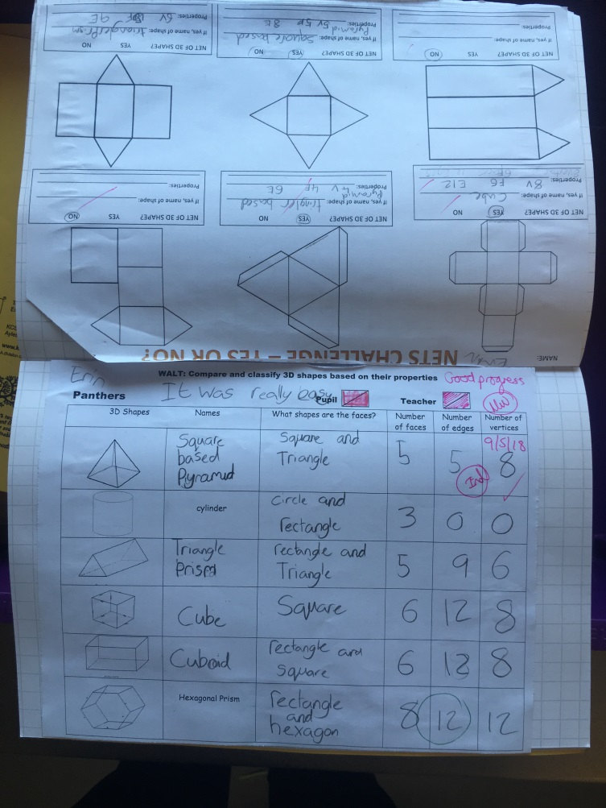
Have a lovely weekend!
The Owls team
