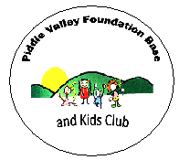
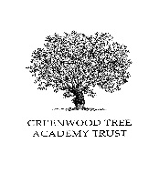
Pupil Premium is additional funding given to publicly funded schools to raise attainment and support the individual child by providing specific support. This can be awarded when families are in receipt of certain benefits. Pupil Premium families are entitled to claim for an annual Clothing Allowance, Free School Meals and Milk.

FREQUENTLY ASKED QUESTIONS
Will my son/daughter qualify for pupil premium funding?
To be eligible you must be in receipt of one of the following benefits:
Income Support
Child Tax Credit, provided they are not entitled to Working Tax Credit and have an annual taxable income that does not exceed £16,190
Income-based Job Seekers’ Allowance
Employment Support Allowance (Income Related)
Guaranteed Element of State Pension Credit
Support under Part VI of the Immigration and Asylum Act 1999
If a parent is entitled to Working Tax Credit during the four-week period immediately after their employment ceases, or after they start to work less than 16 hours per week, their children are also entitled to the PP funding.

Applying for Pupil Premium funding
Your child must attend a school in Dorset County Council area. The County Council will make automated checks to confirm your entitlement. If you qualify, they will tell you immediately and then write to you within three working days to confirm. The arrangements for checking benefit evidence does not disclose how much you receive, or which benefits you receive. Please apply even if you child is receiving the universal free school meals in Reception, Year 1 and Year 2.

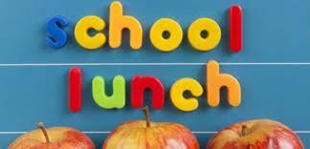
Parents of children who might be entitled area strongly encouraged to apply for pupil premium funding because it enables school to access additional funding which is used to provide additional support to improve access to learning. It is up to the school how the money is spent, but Ofsted check that they used it to help raise attainment of pupils from lower-income families where performance tables show that their attainment tends not to be as good as their more affluent peers. This can add to a lot of additional funding to a school and can be used to really help children to achieve well as they move in through their schooling.

How long will a free school meals award last?
For as long as your child continues to attend a Dorset school and you continue to receive one of the qualifying benefits. You are required to notify us of any changes to your benefit status which may affect your continued entitlement.

My child has just started school and already has brothers and sisters who get free school meals – do I need to reapply?
Yes – you need to re-apply so that the new child can be included in the family’s current free school meals award. Don’t worry if your child is in reception, and is currently only attending part-time. The award can be set in place now, but will only become ‘active’ once the child attends full-time.
Please complete our Pupil Premium application form

The information you provide in this form will be used by the council to confirm receipt of one of the listed welfare benefits. Once this is confirmed, this helps to decide how much money your child’s school will receive each year.
The information will also be used in relation to children in Year 3 or above to decide whether they are eligible for free school meals.

You only need to complete this form once and it will last for the duration of your child’s time at their current school.
Thank you for completing the form and helping to make sure your child’s school is as well funded as possible.
We are committed to ensuring that the personal and sensitive information that we hold about you is protected and kept safe and secure, and we have measures in place to prevent the loss, misuse or alteration of your personal information.
We will use the information you provide to assess entitlement to free school meals. The information may also be shared with other Council departments to offer benefits and services

