

Piddle Valley CE First School
Newsletter No.6 Easter 2018

A message from Mrs Browne…

Standing in front of the school this morning during Collective Worship, looking at all the staff and children wearing a range of hats and massive smiles, reminded me of how fortunate and privileged I am to share in the lives of all our wonderful children here at Piddle Valley – it really was a ‘moment.’ We bid farewell to Miss Georgina Wood, and wish her much luck for the future.
We have also said farewell to Mrs Steven who has decided to step down from her school role as a teaching assistant. She has been part of the school for the last 8 years in many different roles and she will certainly be missed by everyone. We are very pleased that Vickey has agreed to continue to support our ‘Open the Book’ collective Worship sessions and she will continue to be around the school. I would like to wish you all a relaxing and enjoyable holiday with your families and friends during the Easter break.


- To our Year 4 Rugby team for coming first in the recent tournament in Weymouth – well done team!
- Congratulations to Mylo Rushbrook who has graduated from Cerne Valley Beavers to Cubs with an armful of badges! See further in our newsletter to find out how to join your son/daughter.

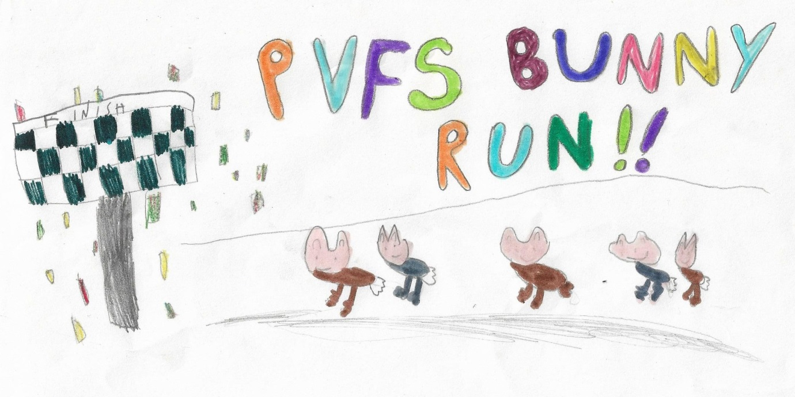
Sunday the 29th of April at 10am, the Friends of Piddle Valley School will be hosting PVFS’s bunny run - 3km, 6km or 9km, and take in a hill or two. The registration fee is £1 per person. Please support our first event of 2018, with your twitchy noses and fluffy tails at the ready, and help us to make a success of it! It’s going to be hopping good fun! (Fancy dress is not obligatory but will be heartily welcomed!) Please see the Friends of Piddle Valley News Letter for further information.
Fundraising
Thank you for supporting the Christmas Jumper Day for Save the Children – we managed to raise £53.28. Thank you everyone
Leila’s Performers
We have been asked by a parent if we could try and gauge interest in a local street dance class to be held once a month at the Old Brewery Hall in Ansty. Leila has a Facebook page and website, but has a great reputation teaching dance with children of all ages.

So that Leila can get an idea of interest in a class please could you email her at
leilas-performers@live.co.uk



DIPPY FAREWELL CELEBRATION

Parents and children are invited to attend the exciting ‘Farewell Celebration for Dippy the Dinosaur’ on Friday 4th May 2018.
Timings are: meet at 4pm at the fountains in Brewery Square to collect a t-shirt
4.30pm – sing the Dippy song
4.40pm – Walk in procession from Brewery Square to Dorset County Museum
5.15pm – ‘Dippy Farewell Celebration’ at the museum speeches, singing and refreshments for the children
6pm – Event ends
If you would like your son/daughter to take part in this unique event please sign them up using this online form – https://goo.gl/forms/MU30zx7CPnfD6eQ53

CERNE VALLEY SCOUT GROUP

Earlier in our newsletter we mentioned how Mylo has recently graduated from Beavers to Cubs at the Cerne Valley Scout Group. They are in a position to accept young people into Beaver Scouts from 6 to 8 years old. If interested please contact Ron Wilkes on 07922 181795 for more information .

Well done everyone for supporting the ‘Wear a Hat for the Day’ event in support of Brain Tumour Research. Our initial count of the donations (before end of day cake sale) totals £124.00 – well done!
Thank you to everyone who brought in a cake – fantastic effort!

Please see the attached sheet with dates for 2018/2019 including allocated inset days and term dates.

School Contact Details: Headteacher: Mrs Jayne Browne
Telephone: 01300 348219
Email: office@piddlevalley.dorset.sch.uk Website: www.piddlevalley.dorset.sch.uk
Address: Piddletrenthide, Nr Dorchester, Dorset, DT2 7QL

