Week beginning 23rd April 2018 – The Owls
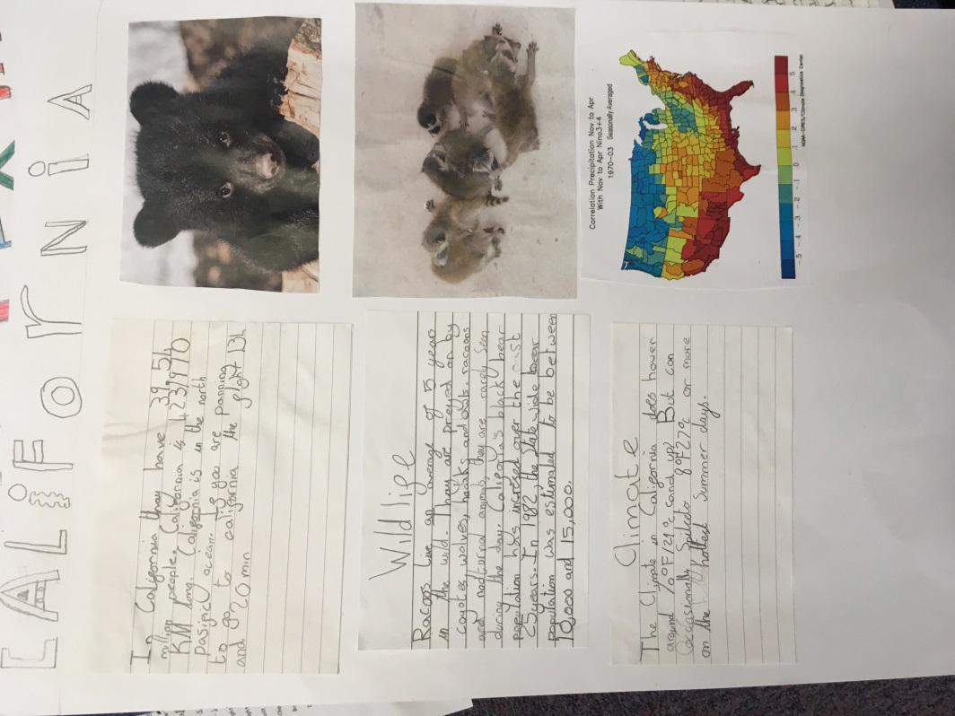
Another busy and enjoyable week as the Owls began the countdown to our Hooke Court residential trip.
In Maths we continued our work on symmetry, with the main focus being: ‘complete a symmetric figure with respect to a specific ‘mirror’ line of symmetry. The class were tasked with creating one side of a mirror line using shapes and colours and then they had to try and reflect it perfectly on the opposite side of the mirror line. They found this fun, but also challenging at times.
For English, we almost finished the final, neat draft of our research of different states for their report writing. We saw Mr Dailey twice this week. Firstly, we had an orienteering festival at St Marys Middle School and then our PE session on Friday was focused on long jump techniques. Wednesday PE session was rain affected and we went into the hall to do multi skills team games.
In science, we learnt about the heart, beats per minute and the effects of exercise on our bodies. For this, the children took their pulse at rest, after moderate exercise and then after one 1 minute of high intensity exercise. We then made conclusions and researched on the iPads to finds answers to our questions. In ICT, we practised debug programs.
Please check your child’s homework – It is very much Hooke Court related!
Have a lovely weekend!
The Owls team

