



BOARD OF EDUCATION
Director of Education: Chris Shepperd

Piddle Valley CE First School

Admissions Policy

2018 - 2019

Introduction

This document sets out the Policy of Piddle Valley Church of England School with respect to Admissions. For the purposes of this policy, the Governing Body is the admission authority.

Recognising its historic foundation, the school/academy will preserve and develop its religious character in accordance with the principles of the Church of England and in partnership with the churches at parish and diocesan level.

The school aims to serve its community by providing an education of the highest quality within the context of Christian belief and practice. It encourages an understanding of the meaning and significance of faith, and promotes Christian values through the experience it offers to all its pupils. Parents have the right to withdraw their children from the daily Christian act of worship and from Religious Education.

Starting school

Parents who wish their children to be admitted to the school, must complete the Common Application Form in line with the Local Authority Co-ordinated Admission Scheme and state Piddle Valley CE First School as one of their preferences, however, this does not guarantee admission should the school be oversubscribed. The Common Application Form is available online at http://www.dorsetforyou.com/schooladmissions.

The forms must be returned to County Hall by the date specified on the form for consideration by the admissions authority. Parents or guardians will receive written notification of the outcome, from the Local Authority, and an offer of a school place should be accepted by the deadline date provided which is set out in the Dorset County Council Co-ordinated Admission Scheme.

Every year the governing body will review and publish information concerning Piddle Valley Church of England First School’s admission policy. This will confirm the maximum number of children to be admitted to the school as a whole, the Pupil Admissions Number (PAN), which is currently 23 and explain how places will be allocated.
In accordance with government legislation, the governing body as part of the Greenwood Tree Academy Trust (GTAT) will consult with the Diocesan Board of Education, the Local Authority and the local schools in respect of their admissions policy.

Aims

The overriding aim of this policy is that it should work for the benefit of all children and parents/guardians in our area. It should be simple to use and assist parents/guardians to take the best decisions on the preferred school for their children. It should contribute to improving standards for all pupils.

The school aims to provide a place for all children whose address is within the designated area, defined as being the area within the ecclesiastical boundaries of the parishes of Alton Pancras, Piddletrenthide with Plush and Piddlehinton as far south as, but not including, Piddlehinton Camp. A map of the area is held in the school office for reference.

The address is the place where the child is permanently resident with his or her parent or parents or legal guardians. Evidence may be requested to show the address, for example, to which any Child Benefit is paid or at which the child is registered with a medical GP together with a recent utilities bill, council tax bill or tenancy agreement. This evidence will be used when reaching a decision on the child’s home address for admissions purposes (including where a child lives with parents with shared responsibility for each part of the week). Parents should not assume that a place will automatically be allocated to their child.

Starting School

A full-time school place in the Reception class is available for children from the September following their 4th birthday. Parents can request that their child attends part-time until the child reaches compulsory school age. Part time in this instance will be set at 5 mornings a week.

Where an offer of a place is made to a child below compulsory school age, parents have the right to defer their child’s entry to school until the following school year. The place is held for that child and is not available to be offered to another child. Entry may not be deferred beyond the beginning of the term after the child’s fifth birthday, nor beyond the academic year for which admission is sought.

Deadline for application

Applications for Reception Year entry for the academic year starting September 2018 need to be formally registered with the Local Authority by the date stated on the Common Admission Form for consideration by the admission authority.

Piddle Valley Church of England First School cannot guarantee places for children when there are no places available as a result of late applications for the normal year of entry or any application that relates to a different year group.

Legislation states that no infant class may exceed 30 pupils.

A decision on the admission of new entrants will be made during the spring term 2018. The parents or guardians will receive written notification of the outcome from the Local Authority on the date determined in the County Council Co-ordinated Primary Scheme (around 16th April 2018).

Late applications, i.e. those received after the deadline for the normal admissions round will not be considered until after all of those which were received on time have been processed, details are available online at http://www.dorsetforyou.com/schooladmissions

Waiting Lists

During the normal admissions round it is always necessary to complete a Local Authority Common Application form to apply for a school place. Registering interest with the school on a “waiting list” before the admissions round guarantees neither a place nor priority within the Oversubscription Criteria. Offers of places will be made by the Local Authority on the school’s behalf.

If the school is oversubscribed for children due to start in 2018 -2019 a waiting list will be maintained. The position on the list will be determined by applying the published over-subscription criteria and not by date of receipt. This will mean a position will change if a later application is received from someone with higher priority according to the Over-subscription Criteria. The existence of a waiting list does not remove the right of appeal against any refusal of a place from any unsuccessful applicant.

Names will only be removed from the list if a written request is received, or if the offer of a place that becomes available is declined. The waiting list will close on 31 December 2018. At that time parents of pupils on existing lists must confirm in writing their wish to be placed on a newly constructed waiting (or continued interest) list which will remain open until 31 March 2019. Looked after children and previously looked after children (as defined within this policy), children who are the subject of a direction by a local authority or children who are allocated to a school in accordance with a Fair Access Protocol will take precedence over any child on the waiting list.

Applications outside the normal admissions round

Applications for 2017-18 entry outside the normal admissions round should be made directly to the school. The governors will process the application according to the following policy and will inform the parents and the LA of the outcome.

Policy

The admissions policy of Piddle Valley CE First School is, while there are adequate places, to offer a place to all applicants irrespective of gender, religion, ethnicity or country of origin, disability or academic ability. Admissions are subject to there being adequate places available in class and adequate teaching capacity/support. Admissions are subject to any constraints upon the school by the relevant authority (Salisbury Diocese, LA, DFE).
Where this school is named in a child’s Statement of Special Educational Needs, the governing body recognises a duty to admit the child to the school.
This school participates in the Local Authority’s Fair Access Protocol.

[NB it is the responsibility of the Governing Body to ensure that all applications which express an interest in their school receive a copy of the school’s supplementary information form and that parents are aware of the time frame for its return.]

Over-subscription Criteria

Where more applications have been received than places available or where to admit would conflict with the school fulfilling class size legislation, the following priorities shall apply in order:

1. LOOKED AFTER CHILDREN or a child who was previously looked after but immediately after being looked after became subject to an adoption, residence, or special guardianship order.

2. VULNERABLE CHILDREN
  - i. children of families with confirmed refugee status
ii. children with a medical condition or disability where written evidence is available from a senior clinical medical officer and the child's general practitioner or specialist showing that it would be detrimental to the child's health not to admit him/her to the school rather than any other. Details of this must accompany the initial application.
iii. Children where either parent has a disability which would make travel to a different school difficult. Evidence from a registered health professional such as a doctor or social worker will be required. Details of this must accompany the initial application.

LIVING WITHIN THE SCHOOL’S DESIGNATED AREA AS DEFINED UNDER ‘AIMS’ ON PAGE 1:

3. CHILDREN OF STAFF
The children of teachers, teaching assistants and all support staff employed at the school for at least 2 years of continuous service at the date of application (or relevant closing date under the LA co-ordinated scheme for normal year entry applications), or who will meet a relevant skill shortage. The term ‘children’ includes adopted, foster and step children, living with that member of staff, in the same household.

4. SIBLINGS
A child is considered in this category if an older sibling is attending the school at the deadline date, and will continue to do so when the sibling is admitted, and where the child lives within the designated area at the same address as the older sibling. Step, half and foster siblings and adopted children are included in the category, as well as the children of couples who have registered a civil partnership.
5. OTHER CHILDREN
Children resident within the designated area who do not qualify under one of the criteria above.

LIVING OUTSIDE THE SCHOOL’S DESIGNATED AREA AS DEFINED UNDER ‘AIMS’ ON PAGE 1:

6. SIBLINGS
A child is considered in this category if an older sibling is attending the school at the deadline date, and will continue to do so when the sibling is admitted, and where the child lives outside the designated area at the same address as the older sibling. Step, half and foster siblings and adopted children are included in the category, as well as the children of couples who have registered a civil partnership.

7. PRACTISING CHRISTIANS
Those children from outside the designated area who are regular practising Christians, (not less than monthly for the last 12 months prior to application), at a recognised church or religious group.

Where parents wish to be given preference on the grounds of their faith within their application for a place at this school, they should complete the school’s supplementary information form (SIF) which is available from the school office. This form must be completed and returned to the school together with all documentary evidence. Confirmation of status may be requested from the relevant priest/pastor.

8. OTHER CHILDREN
Children resident outside the designated area who do not qualify under one of the criteria above.

Pre-School Children

Registration at the Pre-School unit on site of the school will not be considered as a criterion for oversubscription and no priority will be given to such children despite the Pre-school being closely linked to the school.

Oversubscription

If the school is oversubscribed within any category above, the straight-line distance from the child’s home address to the school will be used as the determining factor. Distances will be measured according to the Ordnance Survey eastings and northings for the child’s home address and the school. Those living closer to the school will be given priority.
If two or more children with the same priority for admission, live an indistinguishable distance from the school, but cannot all be admitted, then the available places will be decided by the casting of lots by someone independent of the school or the Local Authority.

Accepting the Offer

Parents must accept the offer by the date set out in the Local Authority Co-ordinated Primary School Admission Scheme. Parents will be asked to reply to the Local Authority. If they do not respond by this date it will be assumed that the place offered has been declined.

Once an offer of a school place has been made, it may only be lawfully withdrawn in very limited circumstances, which include an offer of place based upon a fraudulent or misleading application. Where an offer of place is withdrawn, the application will be considered afresh, and a right of appeal offered if an offer of place is refused.

Appeals Procedure

Parents have a right of appeal to an independent panel against the decision of the Governing Body to refuse application for a school place. Details of the appeals procedure are sent out with all refusal letters.

Enquiries about this policy should be addressed to:
The Chair of Governors, C/O Piddle Valley CE First School, Piddletrenthide, Dorchester, Dorset. DT2 7QL
Piddle Valley CE First School Office: 01300 348 219

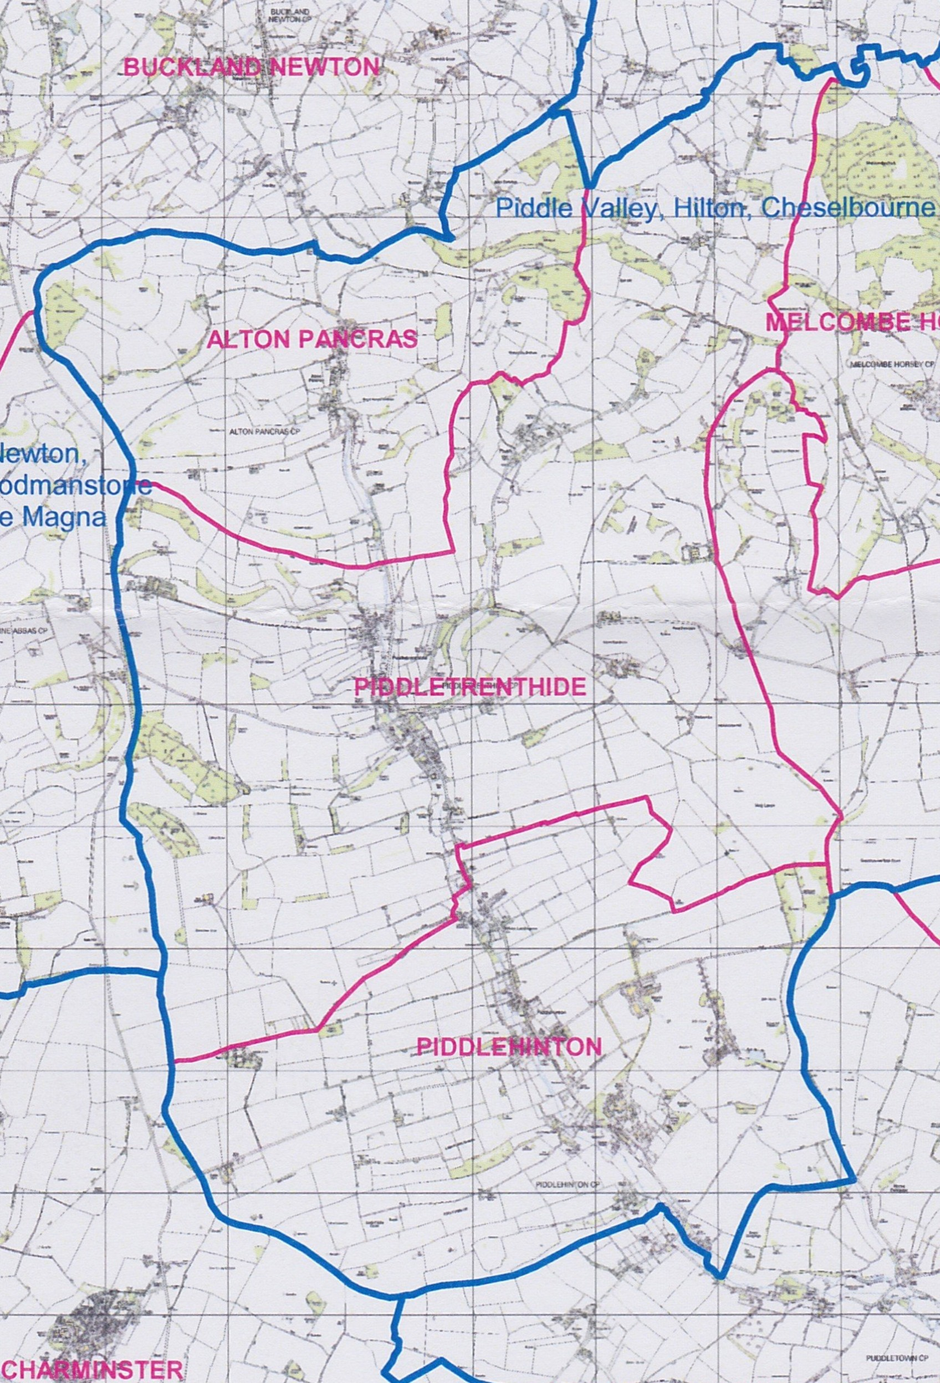
Note: Subject to the above policy and the relevant appeals procedure, decisions regarding admissions will be the responsibility of the Governing Body. Map identifying Piddle Vaparishes:

A looked after child is a child who is (a) in the care of a local authority, or (b) being provided with accommodation by a local authority in the exercise of their social services functions (see the definition in section 22(1) of the Children Act 1989).
An adoption order is an order under section 46 of the Adoption and Children Act 2002
A ‘residence order’ is as an order settling the arrangements to be made as to the person with whom the child is to live under section 8 of the Children Act 1989.
A ‘special guardianship order’ is an order appointing one or more individuals to be a child’s special guardian (or special guardians) under section 14A of the Children Act 1989.
? A ‘recognised church or religious group’ is one that is a member of Churches Together in Britain and Ireland (see ctbi.org.uk) or the Evangelical Alliance (see eauk.org).

