**Piddle Valley CE First School**

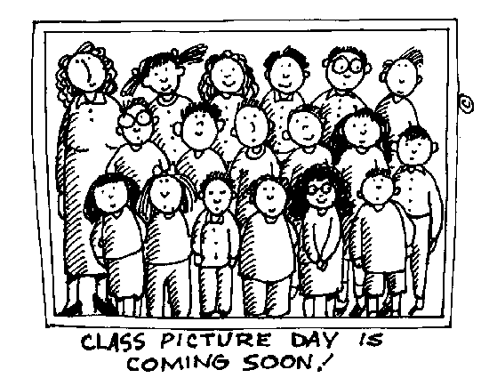

Please note that the school photographer will be with us in school on Thursday 10th September 2020 to take individual photographs of the children. Proofs and order forms will be sent home for you to order the photographs.

Many thanks

Mrs Browne

**Piddle Valley CE First School**



Please note that the school photographer will be with us in school on Thursday 10th September 2020 to take individual photographs of the children. Proofs and order forms will be sent home for you to order the photographs.

Many thanks

Mrs Browne