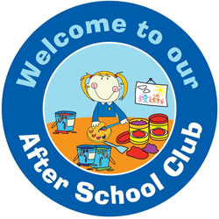
Welcome…
We are delighted that you are considering using the extended school care provision for your child at Piddle Valley CE First School.
We would like to take this opportunity to share with you, our aims and vision for provision.

Our vision…
At Piddle Valley Breakfast and After School club we understand the importance of a relaxed environment where children can choose their own activities both inside and outside, mixing with different aged children in a fun and relaxed environment.
Piddle Valley extended school provision provides parents and families with support and care before school and after the normal school day. This facility is available to all pupils attending Piddle Valley CE First School, Feathers Preschool and past pupils from St Marys Middle School, Puddletown.
You will find us located in the school hall.

Day | Activity
Monday | Painting / Colouring
Tuesday | Games – board / team
Wednesday | Crafts / cooking
Thursday | Construction / small world
Friday | Film / music / dance

Possible programme of activities;

We welcome other ideas and suggestions for our activities so please share your ideas with the staff.
A booking form to secure a place at the After School Club and/or Breakfast club is available from the school office. We have the capacity to accommodate 18 children per session. We are unable to exceed our numbers for each session but we are happy to offer a daily waiting list. We will notify you if a place becomes available.

