12th June 2017

Dear Parents/Carers of Year 3 and 4

Writing Competition
“Lost in the Jungle”

We have a mission for those year 3 and 4 children who choose to accept it.

It is to write a story entitled “Lost in the Jungle”.

Your story must be set in the Jungle. You have taken a trip into the deep dark jungle and become separated from your friends. Tell the story of how you find your way to safety and what happens on your journey? Who or what do you meet on your way?
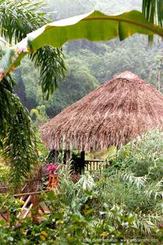
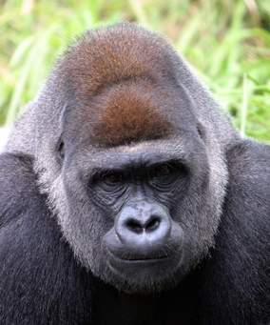
Your story must have no more than 500 words
You must start with the words “Suddenly I turned around and all my friends had disappeared.”

You must include these objects




