Friday 17th July 2020
Dear Parents, Carers and Families,

I would like to start by saying a big hello! I’m Miss Hagon and I, alongside Mrs Hudson will be leading year 4 which this year shall be called AMAZON class. I am very excited to join the Piddle Valley family and cannot wait to share your child’s successes alongside you.
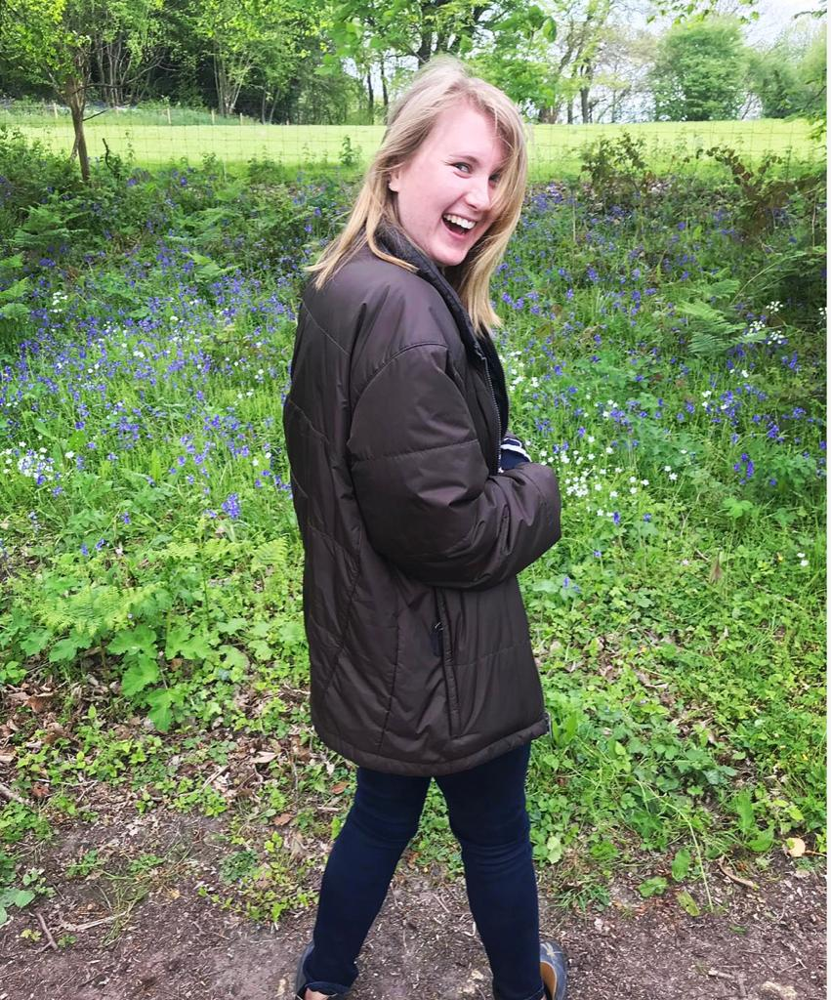
About me:
I have just moved to the area from the sunny Isle of Wight and can’t wait to explore lovely Dorset. My personal interests are gardening and looking after my two pet tortoises Woody and Buzz! I have completed a BA degree in Social Policy at Anglia Ruskin University in Cambridge and completed my PGCE with school direct training through Winchester University.
Class information:
The school gates open for year 4 at 8.35 am and I am keen to use this time before registration for core skills sessions. If you find getting your child to school on time is difficult, please contact the school office in the first instance.
It is very important to me that I work alongside you to ensure that your child is safe, happy, and learning. If you ever want to have a quick chat, then I am available briefly in the morning but preferably at the end of the day. If you would like a more detailed conversation, please contact the office to make an appointment.
Children will be given homework each week and it will consist of maths, literacy, times tables and spellings. Homework will go home on a Friday and will be expected in the following Thursday and spelling quizzes will take place on a Friday morning. I would ask that your child spends quality time each week learning their times tables as there is a national test towards the end of the school year and although we shall be practicing often at school it would be very beneficial for the children to get support at home too.
P.E. will take place this term on Wednesday and Friday, therefore your child will need the appropriate footwear as well as their P.E. kit in for these days. For safety reasons children cannot wear earrings and staff are not permitted to take them out. If your child has pierced ears, please take earrings out on Wednesday and Friday before school.

In Year 4 we will be keeping a ‘Tree of Achievement’ to celebrate the accomplishments of children in the class; please let me know if your child has made an achievement outside school so that we can add it to the display.

I would like to thank you for taking the time to read this letter and I am looking forward to the year ahead! Have a wonderful and safe summer and see you on Wednesday the 2nd of September!
Miss K. Hagon.

