Summary of January 2019 – Mr Wash’s class

Our class class have been kept very bus this month. For English, we have been self and peer assessing our ‘Piddle Rock’ stories and have also moved onto ‘Humorous Poetry’ – the children have really enjoyed this and some excellent work has been produced. Based on the poem, ‘The End of Day School Assembly’ there have been some fantastic creations.
One of my favourite lines was, ‘Mr Wi-Fi’s class logged out’. Also, ‘Mr. Wash’s class bubbled out’ made us all laugh.
In Science we’ve been looking at States of Matter (solids, liquids and gases). The photos below are Yr4’s attempt at showing the molecules arranged when they are in each of these 3 states. See if you can which they are!
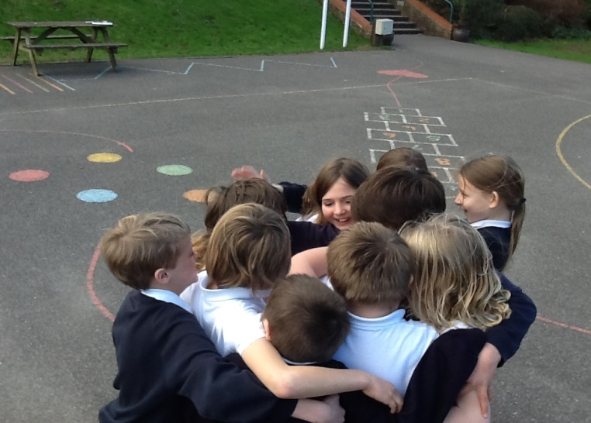
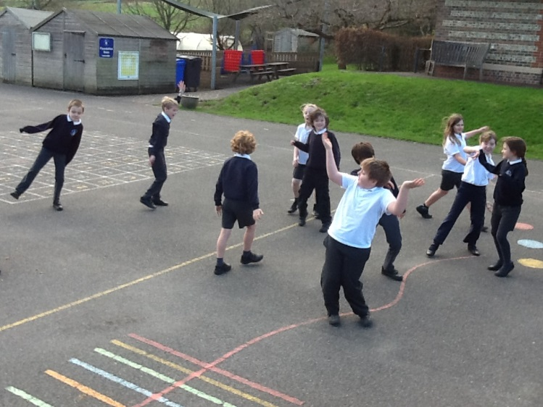

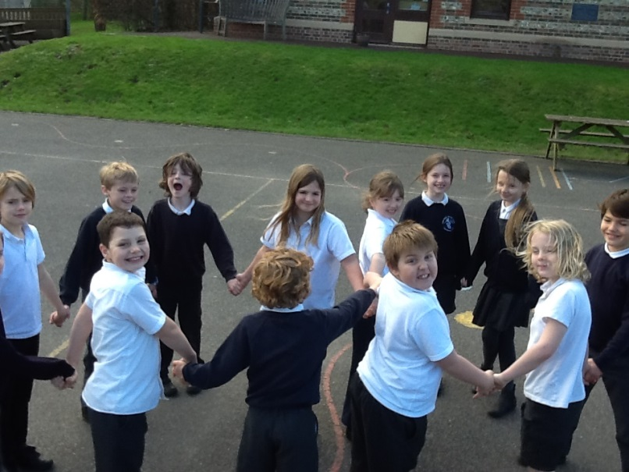

In Maths we moved onto 2D shape, Symmetry and 3D shape. The children found this fun and challenging - with lots of progress being made across the whole class.
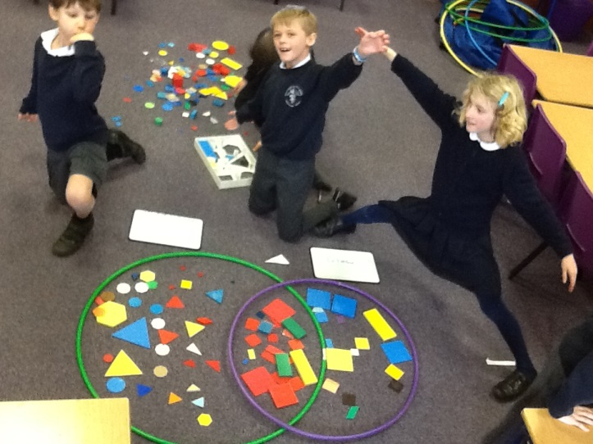
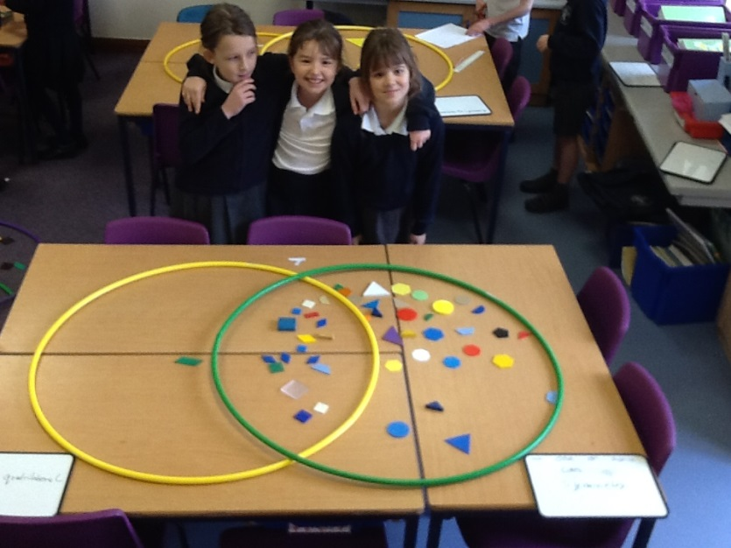

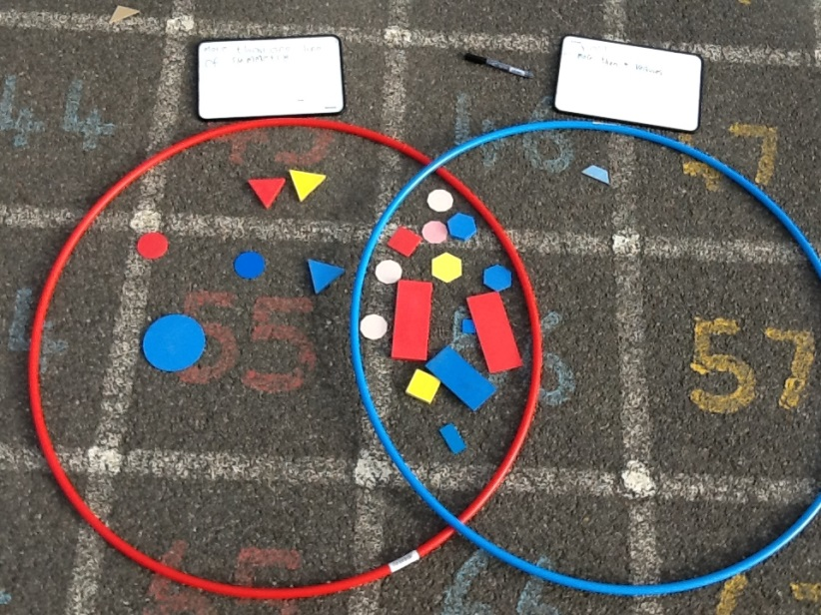

We also continued our PE sessions with Mr Dailey (Gymnastics) and Mr Sandrey (Invasion games), with both commenting on the high level of focus and progression in many of the children.

Thank you
Mr Wash

