2019/2020
Piddle Valley CE First School Admissions Policy
- Introduction

- The academy trust of Piddle Valley CE First School as part of the Greenwood tree Academy Trust is the admission authority and responsible for the admission arrangements of the School. This document sets out the admission arrangements of the School for the academic year 2019/2020.

- The published admission number (PAN) for entry into the School is 23. The School will admit up to the PAN in the normal year of entry which is the Reception year. Where there are more applications for admission than places available at the School, then places will be offered in accordance with the oversubscription criteria at section 3 of this policy.

- Infant Class Size Regulations apply to the normal year of entry (and Year 1 and Year 2). These regulations require classes to be no bigger than 30 children although the PAN may be much lower than 30.

- Where a child has an education, health and care plan (EHCP) which names the School, then that child will be admitted to the School and the number of available places in the PAN will reduce correspondingly. Admission of children with an EHCP is dealt with by the home Local Authority (LA) (which is where you reside).

- When applying to start school in Reception in September 2019 you must apply to your home LA. All applications for first admission must be received by your home LA by the closing date of 15 January 2019. The home LA will make a single offer of a place on 16 April 2019 (or next working day).

- Religious Character of the School

- The School is designated with a religious character. The School’s religious authority is the Diocese of Salisbury. The School must have regard to its religious authority when setting the terms of its admission arrangements.

- Recognising its historic foundation, the School will preserve and develop its religious character in accordance with the principles of the Church of England and in partnership with the churches at parish and diocesan level. The School aims to support children and their families by providing an education of the highest quality within the context of Christian belief and practice. It encourages an understanding of the meaning and significance of faith and promotes Christian values through the experience it offers to all its pupils.

- Oversubscription Criteria
Where the School is oversubscribed (there are more applicants than places available) places will be allocated in accordance with the following criteria and in the following order. Please read the explanatory notes for further guidance.
- Looked After Children or Previously Looked After Children – A child who is in the care of an LA, or was in the care of a LA but immediately after being looked after became subject to an adoption, child arrangement, or special guardianship order.

- Vulnerable Children
A child is eligible in this category where the child has an identified social or medical need.

- Children living in the Catchment Area with a sibling at the School
A child living inside the Catchment Area is eligible for this category where they have a sibling attending the School on the date of application and the sibling will still be attending the School at the time of admission.

- Children living in the Catchment Area

- Children living outside the Catchment Area with a sibling at the School
A child living outside the Catchment Area is eligible for this category where they have a sibling attending the School on the date of application and the sibling will still be attending the School at the time of admission.

- Children living outside the Catchment Area who meet the faith criterion
A child living outside the Catchment Area is eligible for this category where the child is a regular practising Christian at a Recognised Church or Religious Group.

- All other children
Tie Breaker

If there are not enough places to satisfy all the applications under any one criterion, priority will be given to those living nearest the School. The School will adopt the measurement system of Dorset Local Authority to determine the distance from the School to the Home address. Where two or more applicants live an equal distance from the School and it is not possible to differentiate between them, priority will be determined by random allocation through the drawing of lots supervised by someone independent of the School.

Oversubscription Criteria : Explanatory Notes
Catchment Area means the geographical area from which children will be afforded priority for admission to the School. A map indicating the Catchment Area [which [is][includes] the Ecclesiastical Parish] is annexed to this Admission Policy and is available to view on the School website. A hard copy is available at the School office.
Vulnerable Children
- Medical need means where written evidence has been provided from a senior clinical medical officer or the child’s general practitioner / specialist showing that the child’s condition would make it detrimental to the child’s health not to admit him/her to the School. This may include written evidence where the parent has a medical need and/or disability which would make it detrimental for the child to attend a different school; this may be supported by evidence of the child as a young carer. Evidence to be relied upon must be submitted with the Supplemental Information Form and sent to the School on or before 15th January 2019.

- Social Need means where the child is of confirmed refugee status. Written evidence of this from the home LA must be submitted with the Supplemental Information Form and sent to the School on or before 15th January 2019.
Sibling means brother or sister, half brother or sister, adopted brother or sister, step brother or sister, foster brother or sister, or the child of the parent/carer’s partner where the child for whom admission is sought is living in the same family unit as that sibling and at the same address.
Faith Criterion Requirements
- Regular practising Christian means a child who attends a Recognised Church or Religious Group regularly prior to application.

- Regularly means (define: weekly, monthly etc. and for how long; e.g. 6 months / 12 months etc. prior to application).
- Recognised Church or Religious Group means a church that is the same denomination as (or is in fellowship with or partnership with) a member of:
Churches Together in Britain and Ireland (see ctbi.org.uk); the Evangelical Alliance (see eauk.org); the Fellowship of Independent Evangelical Churches (see www.fiec.org.uk); Affinity fellowship of Churches (see www.affinity.org.uk).
Home address means the place where the child resides for the majority of the school week (Sunday to Thursday) with the person/s who legally has care of the child (child care arrangements are excluded). The School may require documentary evidence of house ownership or tenancy together with evidence of the child’s residency at the property.

- Supplementary Information Form (SIF)
- Where seeking priority under the vulnerable children criterion (3b) or the faith criterion (3f) parents must fully complete the relevant part of the SIF and provide the required supporting evidence. Where relying on the faith criterion (3f) the SIF must be signed off by the relevant Church representative. Where relying on the vulnerable children criterion (3b) you must supply evidence to support the application.

- The SIF must be returned to the School office on or before 15th January 2019. The SIF is available on the School website or a paper copy may be requested from the School office.

- Appeals
- Where an application is unsuccessful the parents/carers have the statutory right to bring an appeal against that decision to an independent appeal panel. Details of how to appeal will be included in the letter advising that the application has been unsuccessful.

- The admission appeal timetable is published on the School’s website by 28th February each year.

- Important Information
- Waiting Lists
If the School is oversubscribed for September 2019 entry a waiting list will be maintained until 31st December 2019. The position of the child on the waiting list will correspond with the oversubscription criteria; it will not be based on length of time on the waiting list. The right of appeal at Section 5 remains. You may request your child’s name be removed from the waiting list at any time. If a place is offered but refused then the child’s name will be removed from the waiting list.

- Summer Born children
Summer born children (which refers to children born from 1 April to 31 August) are not required to start school until a full year after the point at which they could first have been admitted – the point at which other children in their age range are beginning year 1. Should the parent wish their child to be admitted to reception, rather than year 1, they may request that the child is admitted out of their normal age group. Please note the following:

- You must make an application for admission to the School for September 2019 entry but make it clear on the application form that you wish your child to enter the reception class in September 2020.

- Discussions with the School are strongly recommended prior to making a decision to decline entry for an entire year and to be admitted to reception in September 2020. Any decision will be on the basis of the circumstances of each case and in the best interests of the child concerned.

- If the request is agreed the September 2019 application may be withdrawn before a place is offered but a fresh application will need to be made for September 2020 entry which will be processed as a fresh application along with all other applications and in accordance with the School’s admission arrangements. PLEASE NOTE that it is possible even if the request is agreed that the child may not be admitted in September 2020 as there is no guarantee of a school place.

- If the request is refused the parent must decide whether to accept the offer of a place for the normal age group, or to refuse it and make an in year application for admission to year one for the September following the child’s fifth birthday.

- Deferred entry and part time attendance below statutory school age
A child may start at the School in the academic year in which he/she reaches the age of 5. Where the child has not yet reached statutory school age (5 years old), the child is entitled to a full time place and parents may choose for their child to attend full time. Alternatively parents may choose for their child to attend part time until their child attains compulsory school age. If parents do not consider their child is ready to start school then they may defer entry altogether to later in the school year but not beyond the point at which the child reaches compulsory school age or not beyond the beginning of the final term in the school year (whichever is the sooner).

- Admission of children outside their normal age group
Parents may seek a place for their child outside their normal age group, for example if the child is gifted and talented or has experienced problems such as ill health.

Such requests should be discussed with the Headteacher as early as possible in the admissions round associated with that child’s date of birth. This will allow the School sufficient time to make a decision regarding the request before the closing date for applications and national offer day. Decisions to admit a pupil outside their normal age group will be based on the circumstances of each case and based on what is in the best interests of the child concerned. We may request supporting professional evidence to assist in the decision-making. There is no legal requirement for this medical or educational evidence to be secured from an appropriate professional. However, failure to provide this may impede our ability to make an informed decision.

- Multiple Birth Applications
Where there are multiple birth applications the PAN will, provided it is practicable, be exceeded or increased at the point of allocation in order to ensure that multiple birth siblings can be allocated places at the School.

- Withdrawal of an Offer
The School may withdraw an offer where it has been offered in error, has been made on the basis of a fraudulent or intentionally misleading application, or a parent has not responded to an offer of a place within a reasonable period of time.

- In Year Admissions
- Applications for in year admission may be submitted at any time during the school year. The application form is on the School website or a paper copy may be requested from the School office.

- Where the School has no spaces available, because the admission of another child would prejudice the efficient education of others at the School or would prejudice the efficient use of resources, or would breach Infant Class Size Regulations, the application will be refused and a right of appeal, as set out in Section 5, will arise.

- The oversubscription criteria at section 3 will be only used where the School is considering more than one in year application at the same time and there are not enough spaces to accept all applicants.

- Further Information
- Important information published by the LA applies to some aspects of school admissions. If you are considering applying for a place at the School you are advised to refer to your home LA’s website.

- If you have any questions in relation to these admission arrangements please contact the School office via email office@piddlevalley.dorset.sch.uk or by phone 01300 348219

- The School will handle all personal data in accordance with the requirements of the Data Protection Act 1998.

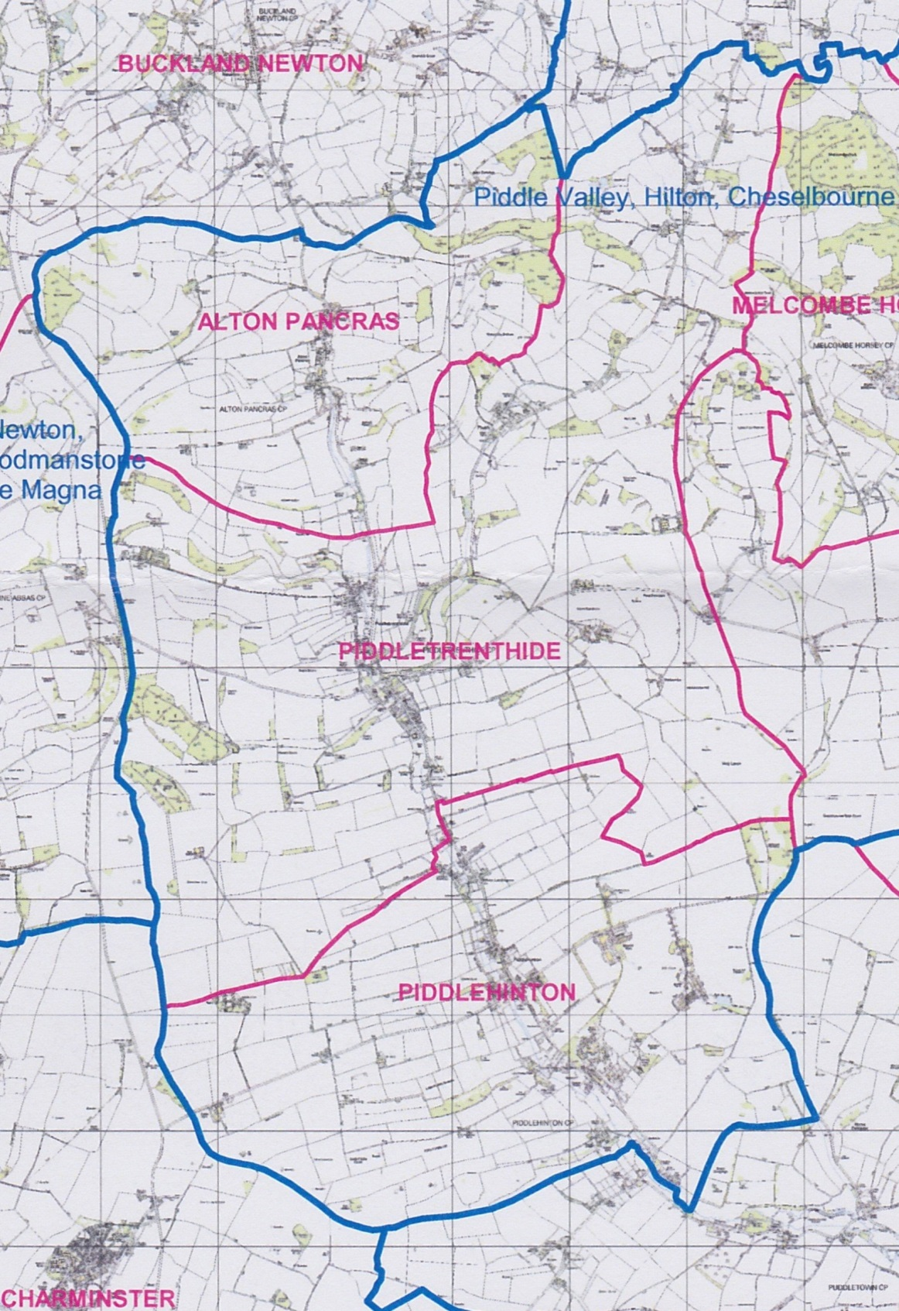
Note: Subject to the above policy and the relevant appeals procedure, decisions regarding admissions will be the responsibility of the Governing Body. Map identifying Piddle Valley parishes:

For a junior school replace “Reception Year” with “Year 3”
Delete this paragraph if you are a junior school
For Junior Schools please delete “Reception” and replace with “Year 3”

